How to Update Files

IMPORTANT: The programs should now all be in the following folder: C:\Egnyte\Shared\GeoRURAL NZ Pro\Climate\Programming.

## Setting up Automatic download

1. This downloading process needs to be done on a computer that you won’t need to use while the downloading occurs, as Mozilla will keep popping up every 10-15 seconds, and if you’re pressing keys when it is popped up it might alter how it works. This downloading process can range in time to up to 10 hours depending on the data type (this would be the case for rainfall). Other data sets may be as little as half an hour
2. Create a list of the station agent numbers to download relevant to that datatype in a CSV called “agents.csv” as shown in the screenshot below. For rainfall, an agents.csv file can be found here: C:\Egnyte\Shared\GeoRURAL NZ Pro\Climate\Programming. Such a list can be generated from QGIS using the file “NZ base QGIS2.8” and then selecting the relevant station type, right clicking it, selecting “Save as” and change the format to CSV, and save a CSV of the information (can ask probably ask Aya or Peter Brown for help if this doesn’t make sense); then open the file, copy and paste the agent numbers into a CSV, calling it “agents.csv”. Put your “agents.csv” into a “base directory” folder, you could make a new one.

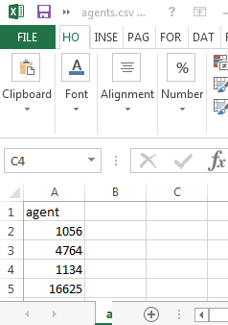

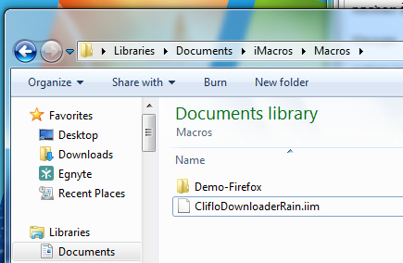

Pasted

1. Open Firefox (if you don’t have it, install it from the internet, see screenshot below and follow their instructions).  
   
2. If imacros is not installed on firefox eg if the red circled button below isn’t present in firefox  
   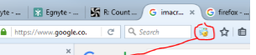   
   If this button above isn’t present, then google “imacros for firefox” (see screenshot below) and download/install it, follow their instructions (once this is installed you should be able to open the iMacros folder)



1. In windows, go to the folder C:\Egnyte\Shared\GeoRURAL NZ Pro\Climate\Programming\iMacros

Copy the relevant imacro eg. “ClifloDownloaderRain.iim” (or, if a different data type, the relevant one in the folder eg. for Vapour Pressure it is “ClifloDownloader9amtemp.iim”). Paste the relevant file into your ‘base directory’ folder. Paste another copy into Documents\iMacros\Macros which should exist if you have now installed iMacros

1. Once this is done (you may need to close and open Firefox first after installing iMacros in previous steps), open Firefox and open iMacros by clicking on the icon in the top right of the screenshot below (circled in red). Right click on “ClifloDownloaderRain.iim” (or other relevant .iim file) on left hand side and select “Edit Macro”.

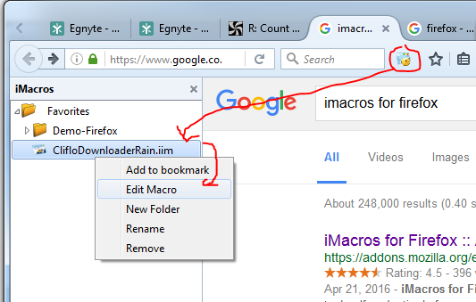

1. In the macro, check the agent number matches in the two circled red lines below in the screenshot (in this example it shows agent number 1024 in both lines). Check the start (upper) and end (lowerdate range is as desired (circled in blue). In the below example, the end date is 1st March 2016 at 0900 hours NZST.  
   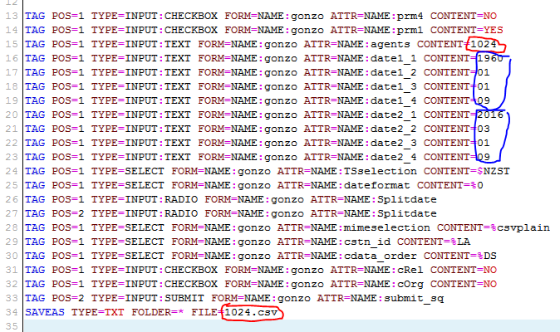  
   For updating, a start date of 6 months before when the previous data was collected is recommended, to catch data that has a delay in arriving. End date can be today’s date or later. Also if you have one, adjust the cliflo username and password to yours (towards the top of the iMacro, the positions are circled in black in the screenshot below). If you haven’t got a cliflo username and password, go to <http://cliflo.niwa.co.nz/>, click “Subscribe On-line” and follow the instructions.

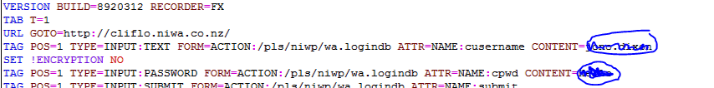  
Once these adjustments are complete on the iMacro, click “save and close” at the bottom of the iMacros Editor window

1. In Mozilla, double click on the iMacro to run it (see screenshot) and check that it downloads what you want. (Should download to Documents\iMacros\Downloads)  
   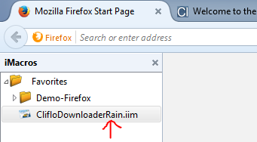  
   IF THIS DOESN’T WORK- some newer versions of iMacro require the month/date/time to be in speech marks eg (see blue annotations below):

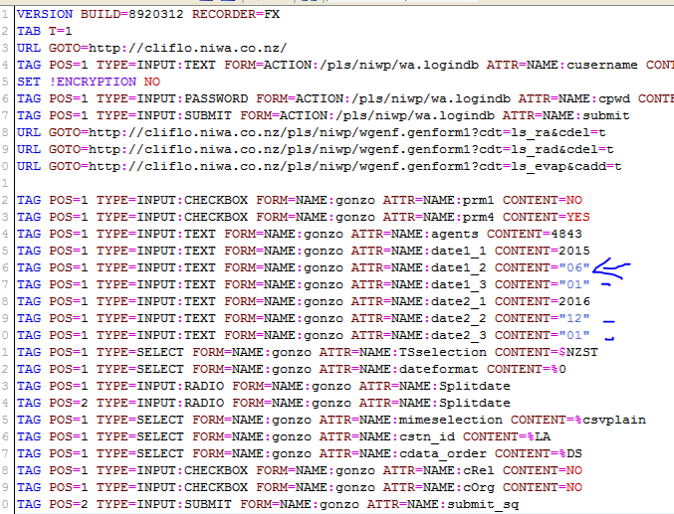

1. Copy the imacro from to Documents\iMacros\Macros back to overwrite your other copy in the “base directory” if you’ve changed it.
2. You will need the freeware programs “R”, and also “R Studio” on your computer. If you don’t have them google “r download” and “RStudio” to download these programs (see screenshots below), there is also a free version of Rstudio.

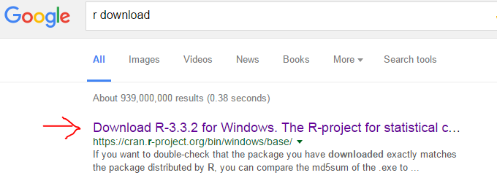

Once R and RStudio are installed, open RStudio and open (Ctrl+O) the “ClifloDownloaderRain” R program ( or other relevant program depending on data type) sourced from C:\Egnyte\Shared\GeoRURAL NZ Pro\Climate\Programming .

In the top left window of Rstudio in the “CifloDownloader” file, change the “BaseDirectory” to that location where the “agent.csv” file and a copy of the relevant imacro “ClifloDownloader…iim” should now be (circled in red below, note you need “\\” between folders as can be seen and at the end).  
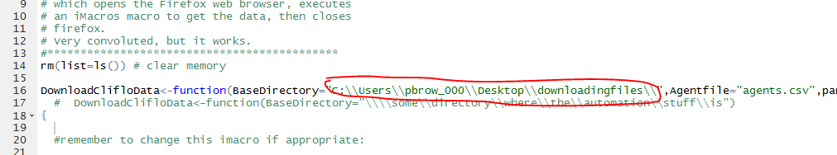  
  
Also check that the .iim file name in the code (example underlined below) matches the relevant imacro in your base directory

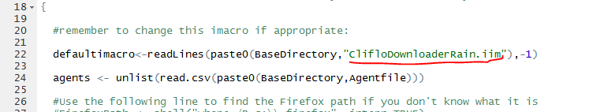

1. Open the Documents\iMacros folder. Click on the address bar. Observe the folder name between “Users” and “Documents” (circled in red below)   
   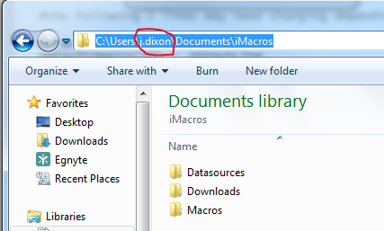
2. If Notepad ++ isn’t installed on your computer, google “notepad++” and select the download option as circled below then follow the instructions to download/install:

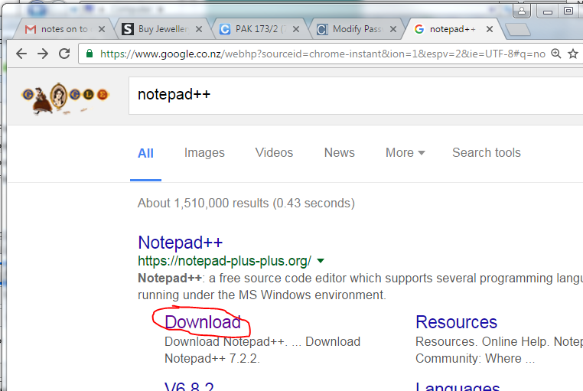

1. Go to the “ClifoDownloader …” R program you have adjusted. In the line starting “CopyShellText” you will need the folder name changed which is circled below to what you observed in the previous step (between Users and documents, eg in my example ‘p.brown’ would need to be changed to ‘j.dixon’). 
2. Check the numbers in the “AgentLine” and the “OutputLine” in the R program…



Correspond to the lines containing the agent number lines in the relevant iMacro in your base directory as shown below (right click on the file and click “edit with Notepad ++”).:





Source the R program by clicking the button circled below.  
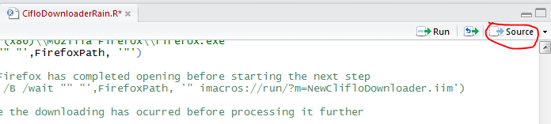  
and hopefully it starts downloading! It should download to /Documents/iMacros/Downloads.   
  
Notes: Keep an eye out for if it starts downloading consistently small files (eg 1kb) in case your cliflo subscription has run out. You can confirm this by opening the file, and check whether at the bottom it says “Number of rows remaining in subscription = 0”. If this is the case, you will need to go to <http://cliflo.niwa.co.nz/> and “Renew Subscription”. Find the file that was first downloaded where it says “Number of rows remaining in subscription = 0”. Then you will need to redownload this file and all the files after that. In order to download just these files, change your agents.csv file so it only has the agent numbers you want to redownload, and save it. Source the program again and it should start downloading these files.

If any of the downloaded files are 0kb in size , this is likely due to the program interrupting the download, and these files will need to be redownloaded. In order to redownload just these files, change your agents.csv file so it only has the agent numbers you want to redownload, and save it. Go to the “ClifoDownloader Rain” R program (or equivalent), in the line that says Sys.sleep (see below), change the value to Sys.sleep(30) (this should ensure that the program delays long enough for it to be captured).   
  


Source the program again and it should start downloading these files. If Mozilla does not pop up and the program appears to have finished, check that at the bottom of the program it says “DownloadClifloData()”.  
  
  
Setting up the Data

1. Copy the raw downloaded files (from previous section in /Documents/iMacros/Downloads) into an empty download folder of your choosing. Check they are all the right file type using “check file type.R”. Make sure you change the rawDataDirectory to where your downloads are, and the searchFor phrase (see below) to the exact phrase that appears in a download file for that data type, ie for radiation it is "Radiation: Daily Global". If the output is agent numbers, something appears to be wrong for those agent number files. If there is a non-csv file in the folder (such as one called profiler), delete it   
   It should either print those stations that it thinks has problems, or say “All have searchFor phrase…”

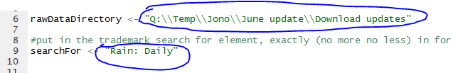

1. Check they have the right agent file name using “check agent number matches.R”.  
   Change the raw directory and it should work. It should either print those stations that it thinks has problems, or say “All have matching agent number…”
2. Open the appropriate Reformatter…R program. Set the different directories (folders) according to the comments in the code (FromDirectory, ToDirectory,FaultyDirectory - the FromDirectory should hold the raw download files, the ToDirectory is wherever you want to write the files). For ‘ReformatterRain 72 48 24’ you should choose option 1 or 2: see comments in the code of that reformatter.
3. Optional depending on if it’s relevant to the data type: (Create Tier 1 stations using Peter’s Climate series tool, you can use the Logs as a subjective guide of which stations to extend and with what, which could be found, for example in C:\Egnyte\Shared\GeoRURAL NZ Pro\Climate\Screen temp 9am\Teir 1 Stations\Documentation. Tier station file names should have the agent number followed by “ out” and you can then add a phrase like “maxT” after that if you wish.)

# Joining the data

Note **Packages**: For some these programs there may be an error message “there is no package called ‘…’”.

In these cases you won’t have the required “package” loaded. In order to add the required package go to ‘Tools’/’Install packages…’ as shown in screenshot below.

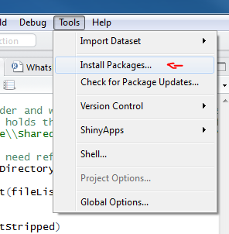

1. Open “Join converted data.R”

Change the directories (“originalConvertedDirectory”, “updatesConvertedDirectory”, “WriteJoinedDirectory”) to what you want (“originalConvertedDirectory” is the original converted files on Egnyte you want to update -I tend to copy these into my own folder). Data from “originalConvertedDirectory” will be prioritized over duplicate days in “updatesConvertedDirectory. Original converted will be the Cliflo converted files you want to join the updated converted files to (eg for rainfall it is in C:\Egnyte\Shared\GeoRURAL NZ Pro\Climate\Rainfall\Cliflo converted\Rainfall National 72 48 24 joined)

1. Running this should paste the data together appropriately. It will also add any new files in the updates that weren’t in the original. I typically check one or two files to make sure it’s joining fine.

# Running the Extension Program

1. Create “station info” folder. Put a station info list CSV for that type of data, there should be one in C:\Egnyte\Shared\GeoRURAL NZ Pro\Climate\Programming for Rain which should give a comprehensive list for most data types, and a separate one for PET. (alternatively can be created by QGIS by right clicking on the relevant data type and saving as csv). For the program to work it requires the agent number in the first column, the NZTM easting in the 11th column, northing in the 12th column as should be the case. Have the “station info” folder empty apart from the station info list CSV.
2. Optional: Potentially helpful to check that all the relevant agent numbers are contained within the station info list to avoid errors when running data extension. This can be done by the following
3. copying the list of agent numbers from the station info list csv into a standalone csv (contains only the numbers)
4. generating a CSV list of file agent numbers in the relevant converted folder. This can be done using “WriteFileListCSV.R” in C:\Egnyte\Shared\GeoRURAL NZ Pro\Climate\Programming .Change the FromDirectory, and remember to remove the file from the folder afterwards.
5. once the two single CSV list files are created, you can see what’s missing from each list using “WhatsMissing From TwoCSVlists.R”.  
   It doesn’t matter really if something in the info list is missing from file list, however if the info list doesn’t have a file agent number, the extension program will have an error.)
6. Open (or perhaps copy it another location and open if you think you may break it!) extendSiteData2.R located in C:\Egnyte\Shared\GeoRURAL NZ Pro\Climate\Programming
7. **IMPORTANT:** Change the ‘WriteToDirectory’ address shown below to where you want it to write to, so that you don’t overwrite something else! (you can search for this using Ctr+ F and search for ‘WriteToDirectory <’, towards the bottom, it should look like the screenshot below)   
   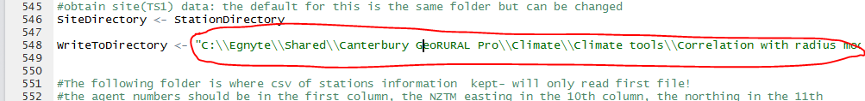
8. Change the “DataType” to the appropriate type. It should be 1 for PET, radiation, rain, wind or vapour pressure. It should be 2 for Temperature and 3 for radiation.
9. Change “StationDirectory” to the folder where your converted/joined files are (and tier stations for data types other than rain- find them on egnyte) all in the one folder.
10. Put only your station info list CSV( mentioned previously) in a folder and set the “StationInfoDirectory” to there. Change “finishDate” to today’s date (YYYY/MM/DD).
11. Check the “kmRadiusLimit” is what you want (typically 75 for Rain, 200 for others)
12. Using Ctrl+F, search for “month that match”, it should take you to a part of the code as shown below. Check the criteria is what you want for if a station is used to extend the data: typically 90 days is used for Rainfall, 30 for others.  
    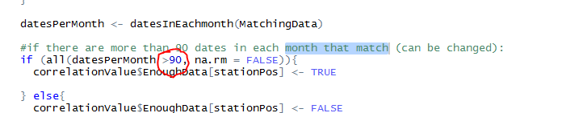
13. Set it going, hopefully it works! If there is an error that mentions “kmDistanceBetween <= kmRadiusLimit” the station infolist is probably not set up correctly.
14. I usually “test” it by looking at a few files and seeing if the order of things being correlated looks ok (with 9am observations it’s often quite erratic but I’m guessing that’s the nature of it). I’ll generally compare some with the old versions to see that they look similar. I’ll often check in QGIS which eligible stations it’s most or least correlated with. Sometimes for the top two most correlated I produce the equivalent extended files using Peter’s climate tool program, and check it’s filling those as it should
15. For documentation, create a file called for example “Rain 4 July 2016 spec notes”. Copy into this file the code from “#USERS AREA” down to “kmRadiusLimit”. Also copy the line that starts “if (all(datesPerMonth >“ . Have this document copied into C:\Egnyte\Shared\GeoRURAL NZ Pro\Climate\(*datatype eg.Rainfall)* so that people know what parameters you used for the run.

Sometimes there is an warning at the end which says:

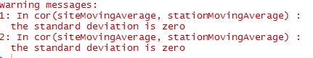

From my experience there hasn’t been any issue with this (see notes in Bugs Log 13/01/2016)

# Files to Update in Egnyte

1. For downloaded data In C:\Egnyte\Shared\GeoRURAL NZ Pro\Climate\...\Cliflo download\ (where ‘…’ is the downloaded data type) make a folder ideally of the form “YYYYMDD to YYYYMMDD” and copy the downloaded updating files into this.
2. For converted data In C:\Egnyte\Shared\GeoRURAL NZ Pro\Climate\...\Cliflo converted (where ‘…’ is the downloaded data type) make a folder of the form “YYYYMDD to YYYYMMDD” and copy the converted updating files into this. Also update “Rainfall National 72 48 24 joined” so it has the full converted joined data used for the data extension.
3. Extended Data : finally replace/overwrite the extended folder (C:\Egnyte\Shared\GeoRURAL NZ Pro\Climate\...\Extended) with the updated extended files.

# Post processing

1. Open the following programs: “Table of Station Correlations.R”, “Table of Station Values.R”, “Table of Station Origins.R”. Adjust the FromDirectory to the folder where your extended files are and change the WriteToDirectory to where you want. Source each program to produce those files.
2. Open the “Table of unextended values.R” program. Adjust the FromDirectory to the folder where your converted (joined) files are (NOT the extended files) and change the WriteToDirectory to where you want. Source the program.
3. Open ‘Post processing summary2.R’ . Check you have the right dataType, startIrrYearRange and baseDirectory in “Post processing summary2.R” and save it. Note that you need a table of the values produced by “Table of Station Values.R” (executed earlier). This table needs to be in the baseDirectory you set in “Post processing summary2.R” and be the only file in that folder ending in ” extended.csv” (see notes in program).
4. Open “Count Summary.R” check the irrigation year range is correct for your data. In the line that looks like



check the address is right for the “Post processing summary2.R” program you adjusted in the previous step. Source the Count Summary and it should run both programs

1. Open “Mean Max or Min summary.R”. Select the option (1,2 or 3 for mean, max or min), data type and year range. If you don’t have the ExtendedSpreadData in Rstudio’s memory or baseDirectory from the previous programs( eg the following isn’t present:  
    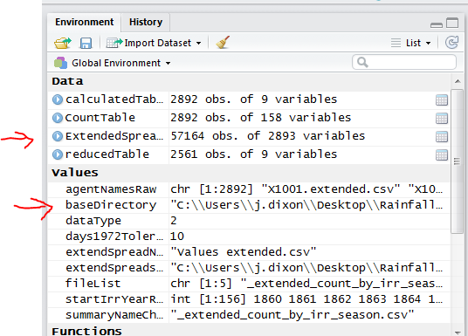 )  
     
   If there is no ExtendedSpreadsheetData/baseDirectory unlike what can be seen arrowed in red in the screenshot above, then uncomment the following lines:



And also uncomment (Ctrl+Shift+C):

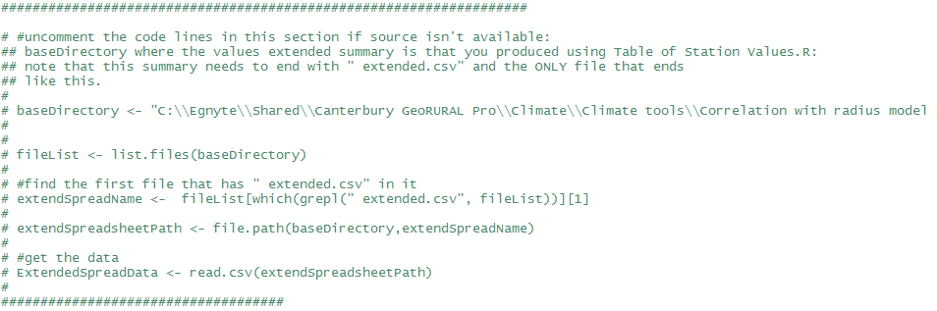  
If you have uncommented the code lines above, change the baseDirectory. It should be the same baseDirectory as you use in the earlier step (step 15 in this section about using the Post Processing summary2. R program).   
Once this step is satisfied, source the program “Mean Max or Min summary.R”. (Sometimes I found there was an NA:NaN error of some sort which seemed to resolve itself when I reran it). If you want more than one of the options, change the option and source it again etc.

1. Open “Unextended Count Summary.R”. Change the base directory to where your unextended summary is that was produced by “Table of unextended values.R”, make sure the table is the only file that ends with “unextended.csv” in the name, also change the date range appropriately. Once this is done, source the “Unextended Count Summary.R” program.
2. Open “writeRainCorrelationStatsAdjusted2.R”. Change the baseDirectory to where you have your “Correlation extended summary.csv” produced by the “Table of Station Correlations.R” program. Change the finalIrrYear to the final full irrigation year you have available (see code). Choose numberOfPeriods to be either 2 or 3. Change startIrrYear1/2/3 to the starting irrigation year for each period. Source the program once finished “_Correlation_Summary.csv” should appear in your baseDirectory. (There will likely be some warning messages saying “NAs introduced by coercion” but this should be fine, I believe this is caused by extended files that use their own Tier 1 station version for extension- which registers a correlation value of “N.A.”)   
   (Note: this program is an adjusted form of Caroline’s program “writeRainCorrelationStats.R” which is also in the programming folder)